Colleen’s Update:

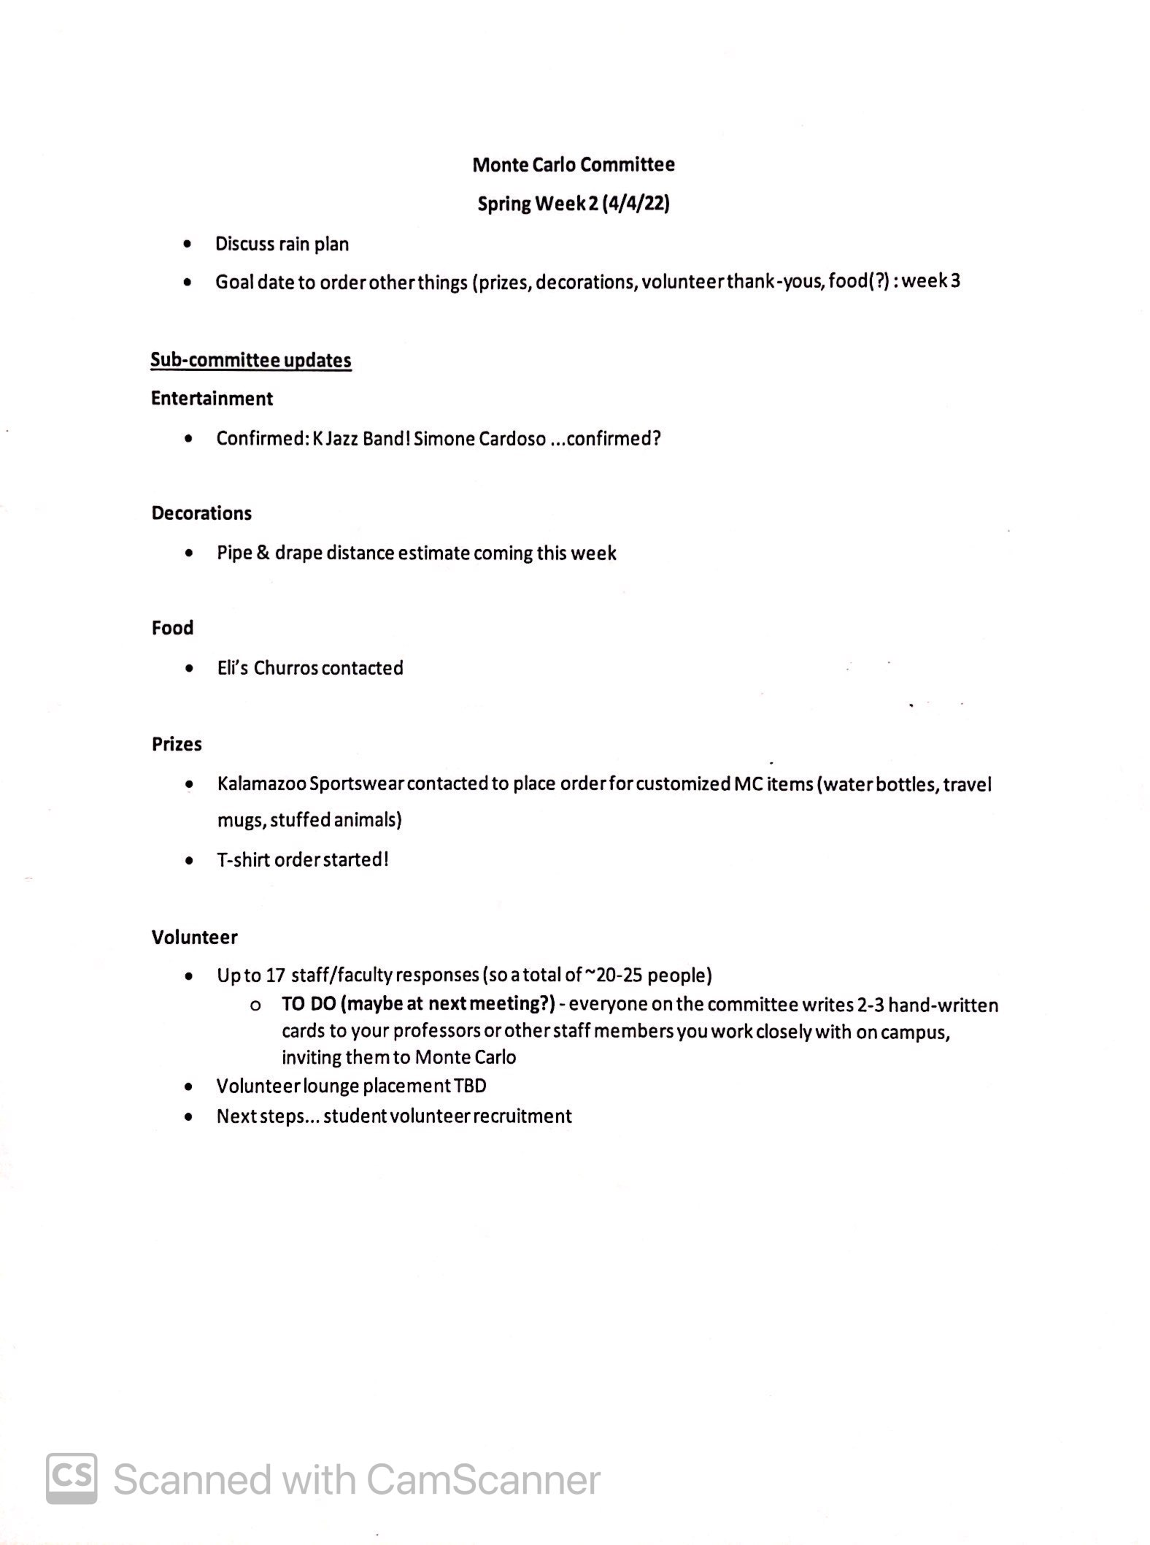

Hick’s building max capacity of 700 – 750.

Rain Day plan

-Food trucks will be moved into the Banquet Hall.

-Divide into three scenarios: no rain – sprinkly rain – heavy rain.

-Have tents to cover over entertainment.

-OPINION: put facilities into another building ( i.e. Chapel) in case of rain.

Entertainment:

+ Two tents to operate entertainments.

+ Spinning wheel for games.

+ Corn Hole

10x10 tent: will incorporate glow props to enhance the concert / sand art souvenier to make art / make ribbonish.

Decorations:

+Balloon lady art will help with making decoration props.

Food:

+Eli’s Churro

+Donut’s ( once appeared at KFest 2021).

Estelle update: what they are hoping to get will be updated soon.

-Zhi and Claudia will volunteer with help with the Donut vendor.

Volunteer:

-Has placed order.

-Wait for student volunteers to gather up and then will talk about the updates.

-Volunteer lounge TBD.

-Recruitment: has finalized the email draft to be sent out.

Total of 50 - 60 people.

10-15: for clean up.

Staff/Faculty will work on the casinos.

-Make a manual book for the student leaders.

-Make a thank you note

Guests?:

Warn people about the chance of rain. Welcomed subject to COVID/rain.